**5.1.4 Petrofacies Identification**

Four predominant rock types have been identified based on drill cuttings and core analysis descriptions. These include clays / shales, tuffs, conglomerates and effusivos (basalts), however there are a multitude of transitional facies that exist between these four major facies. The rock types and a description from cuttings of each are as follows:

1. Clay Facies:
   1. CLAY (55%): greenish grey and beige, very incoherent, bentoitic, little calcareous.
   2. Loam (10%): white and cream very clear, slightly fosilífera, incoherent, somewhat microgranular.
   3. Limestone (10%): yellow and white, fossils, microgranular, clayey with fine sandy grains of quartz.
   4. Limestone (10%): white, fragmentary, calcarenite, hard in thin layers, also calcilutites with large fossils and grains of andesites grey and green.
   5. Sandstone (10%): white and very clear green with little calcareous cement, abundant crystals of quartz and grains of andesites, scarce tuffs.
   6. Conglomerate (5%): rounded grains mainly of green and grey andesites often with attached pyrite aggregates.
2. Tuff facies:
   1. Tuff (60%): sandy, grey, greenish and white, coarse-grained, lytic and crystalline texture, consolidated, some slightly pelitized, ithoclasts of grren and dark grey andesites, quartz, broken plagioclase, chlorite, pyrite, amphibole and little biotite crystals.
   2. Andesite (30%): clasts inside the tuffs, dark green and grey with phenocrysts of tabular plagioclase, well defined, hard.
   3. Limestone (10%): shaley, dark brown to black, sometimes argillite soil, recrystallized, more and less coherent with some calcitic, spherical bioclasts.
   4. Abundant pyrite in the samples in the form of aggregates and concretions.
   5. Small traces of oxidized oil.
3. Shale facies:
   1. Shale (35%): grey, dark beige and greenish grey, calcareous, silty and sometimes sandy components, the layers are thin, open and sealed fractures cemented by calcite.
   2. Sandstone (30%): brown to sandy tuff, white and greenish grey, calcareous cement is mixed with volcanic glass and transitions to tuff, fragments of quartz, feldspars, green and grey andesites, reddish brown basalt and olive chlorite.
   3. Tuff (20%): sandy, light olive green and greenish cream. Porous, incoherent, with slightly pelitizado glass, with abundant broken crystals of quartz, plagioclase, chlorite
4. Conglomerate facies:
   1. Andesite (60%): various colors, hardness and texture, the dark greys and greens predominate but there are also browns, light greens.
   2. Plagioclase and large microcline in elongated strips, very hard but sometimes apparently somewhat earthy, fractured, impregnated with rusty reddish oil. Sometimes zeolite fractures, vesicles with chlorite and large crystals of dark green amphibole.
   3. Tuff (30%): crystalline and lithic, coarse-grained, dark brown, light green and beige, some altered to clay, other hard and coherent, with broken crystals of quartz and plagioclase. Tuffs sometimes associated with oxidized oil.
   4. Clay (10%): olive green and beige, friable, with volcanic glass. bentonite
5. Clays and Conglomerate facies:
   1. Clay (50%): grey and olive green, very unconsolidated, little bentonite, limited volcanic glass.
   2. Conglomerate (30%): tuffs with fragments of green and grey andesites, cream color, greenish yellow and light green with marked fluid texture, some fragments stained with light reddish oil, slightly oxidized. Tuffs are broken and lithoclast crystals, also inlays of black and fibrous obsidian as well as reddish black biotite crystals, little consolidated by pelitization, rare fragments of white quartz diorite, mottled in dark green, very hard.
   3. Sandstone (15%): medium grained with white calcareous cement, with crystals of quartz, plagioclase, micas and fragments of andesites and tuffs.
   4. Limestone (5%), white, sandy, clayey, unconsolidated, microgranular, hard calcarentie.

Bentonite is the dominant clay present and is described as a soft, plastic clay formed by the chemical alteration of volcanic ash produced by volcanism and hydrothermal activity. Bentonite is composed of hydrous aluminum silicates in the form of extremely small particals (suggesting high irreducible wáter saturation). These hydrous aluminum silicates are composed essentially of montmorillonite and related minerals of the smectite group. These group of clays swell in the presence of water and possess high cation exchange capacities. The theoretical formula for montmorillonite is (OH)4Si8Al4O20·*n*H2O.

The rock facies as described are very complex to model and require many additional electric logs over-and-above the few logs we have available. Because of the under-determination of many minerals and few logs no cross-plotting techniques could be employed. We have been left with a minimal log suite and therefore only able to establish simple log versus facies correlation methods.

**5.1.5 Petrofacies Methodology**

The first step taken was to digitize the lithologies indicated on the Composite Log Displays (well sight strip logs). This involved entering the depth and the corresponding lithology for each of the available 90 wells, Figure 1 illustrates a typical Composite Log.

Figure 1: Composite Log Display: Depth vs. Lithology / Facies

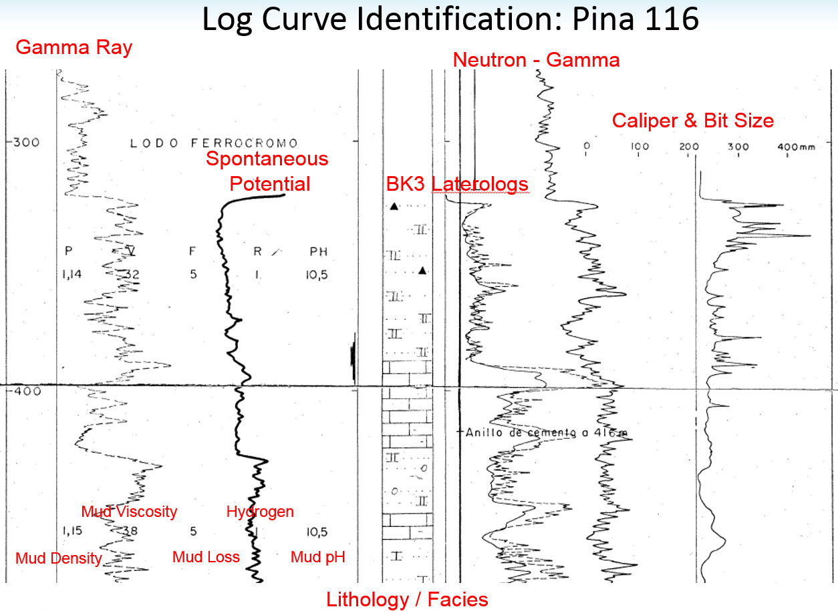

Once loaded the lithologies were compared against the gamma ray (both total, uranium, thorium, and potassium curves), the neutron, the sonic and the resistivity logs. What was identified very early was the correlation of the deep resistivity to changes in the lithologies.

It was apparent that clays / shales possessed the lowest resistivity (under 2.5 ohm) of all rock types and throughout the clay interval the resistivity logs remained essentially flat and featureless. The conglomerates show marginally higher resistivity falling between 2.0 to 3.75 ohm. Their log signature was much more erratic than that shown by the clays. As the ohm increased between a range of 2.75 and 15.0 ohm tuffs were predominantly indicated by the Composite Log displays. And finally, when resistivity measurements exceeded 15.0 ohm, basalts (Efusivos) were indicated by the Composite Log display. Working in our favour was the fact that the resistivity logs were very consistent in their log signature over the clay intervals. When normalizing was required, normalization bulk shift values were calculated based on the clay resistivity. We were also fortunate in the fact that almost every well had a resistivity log. Confidence in the rock type ranges grew as well after well showed similar consistency. Table 1 provides the classification of petrofacies type and resistivity boundaries.

Table 1: Petrofacies Classification



Figure 2 graphically illustrates the correlation of the cuttings lithology (Track 3) and the resistivity log (Track 8). Vertical dashed lines assist in showing the boundaries between the various facies. Also shown in Track 4 is a gamma ray, correlation to rock type exists but is not as consistent as the resistivity approach. Tracks 5 through 7 show a Spectral Gamma Ray illustrating the thorium, uranium and potassium levels, as the basalts (Efusivos) are reached high levels of each element are recorded.

Figure 2: Distribution of Rock Type Cut Offs

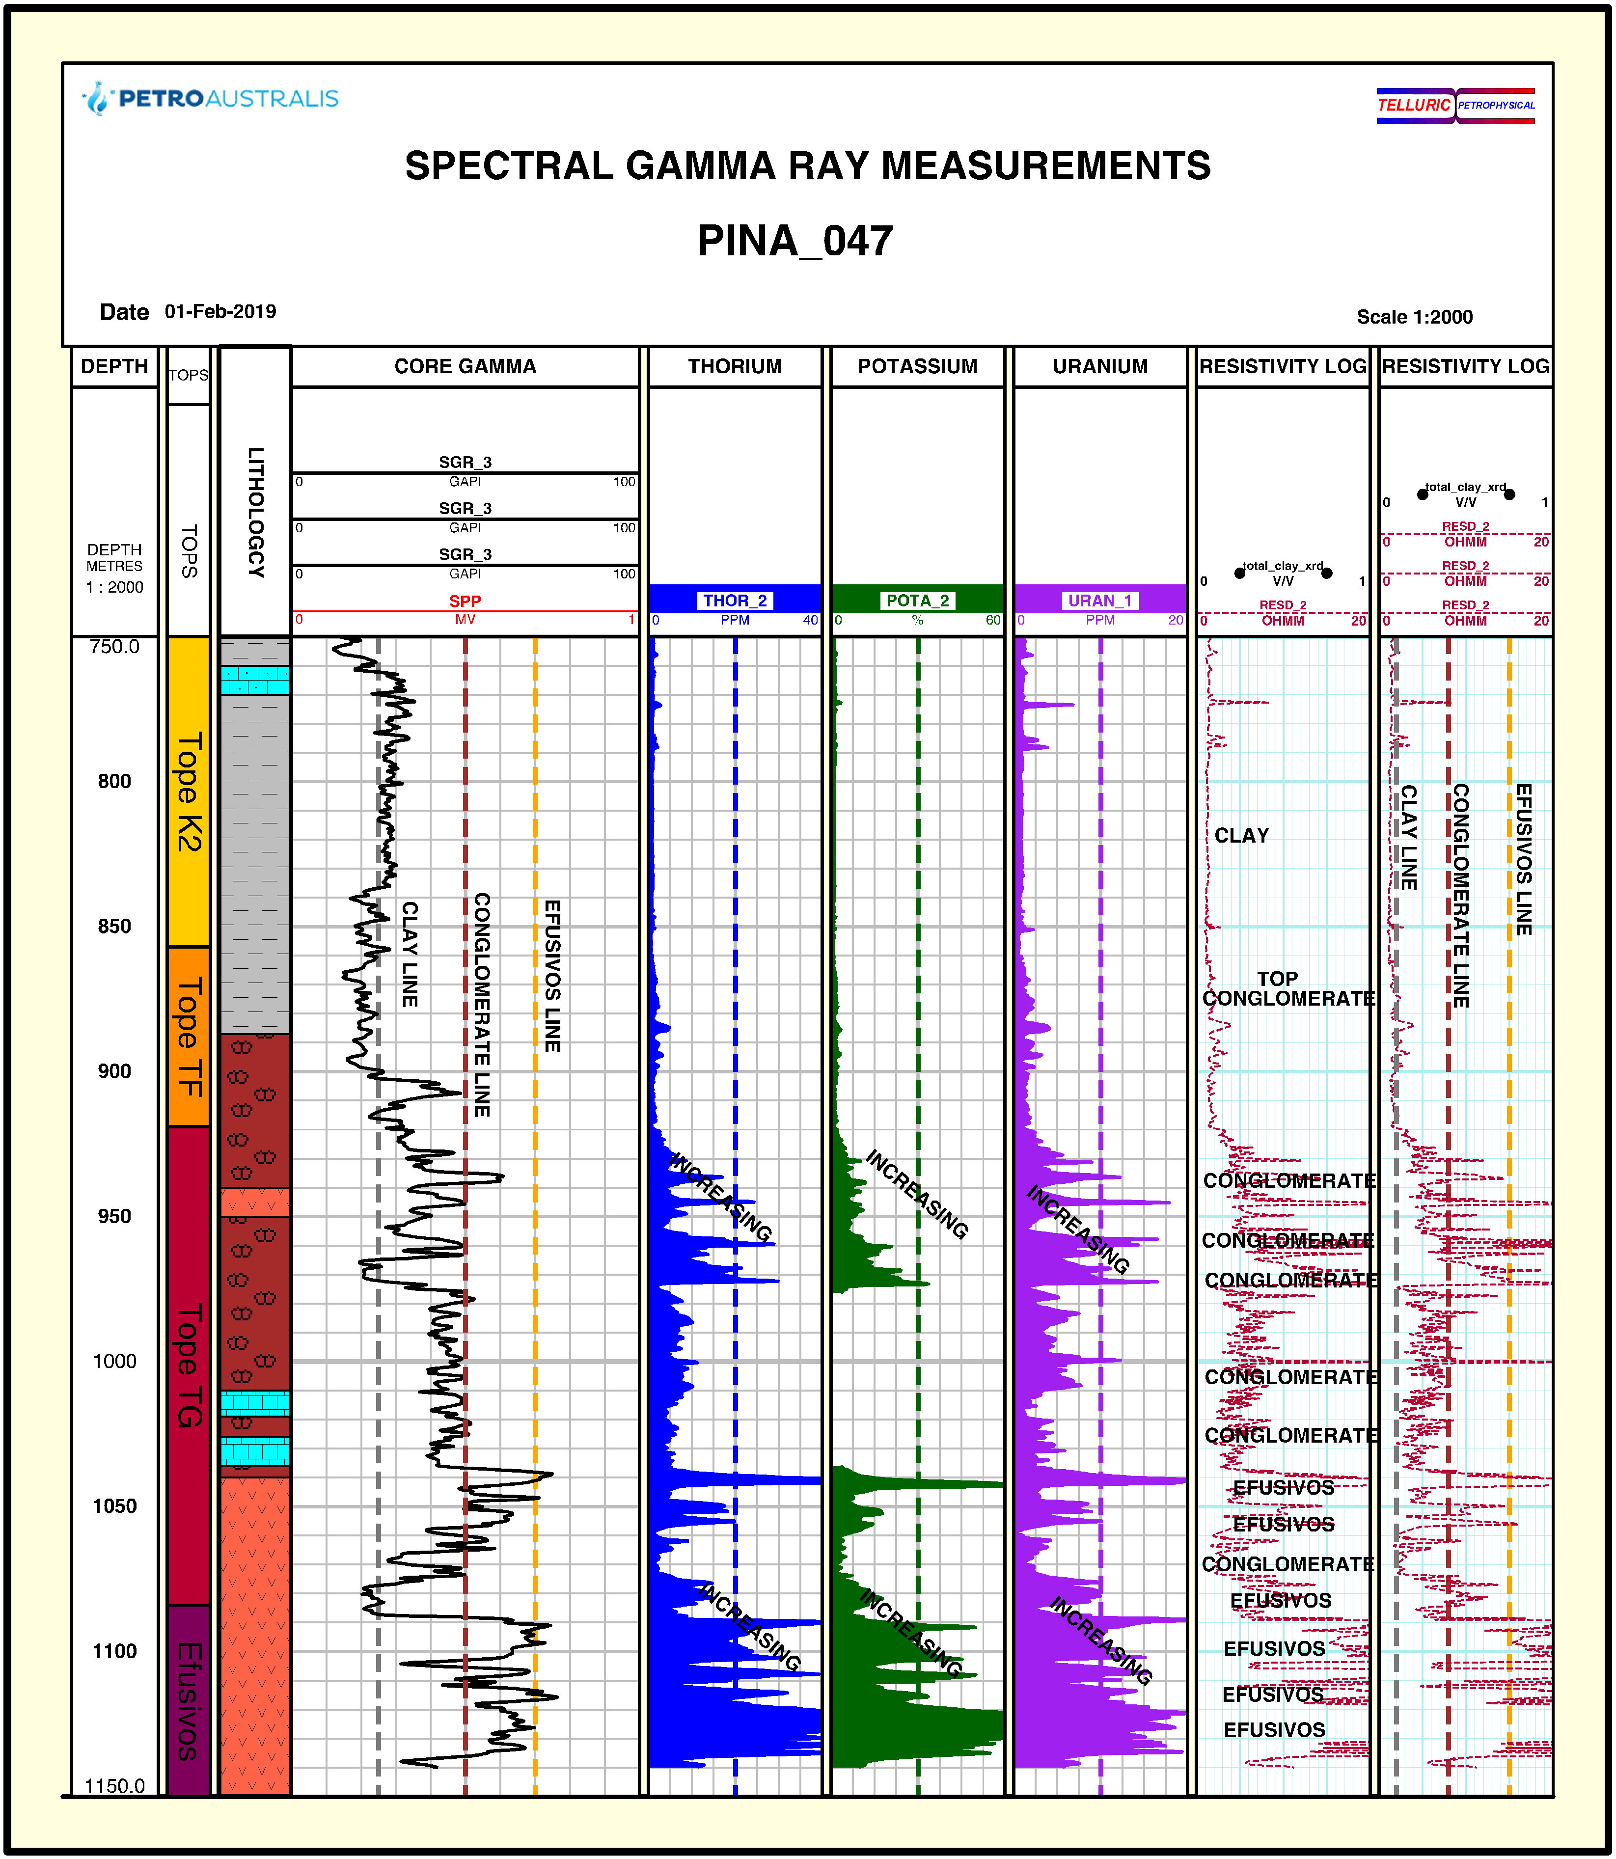

Figure 3 is a two well cross-section through the Brujo Field showing the consistency of log calculated petrofacies to cuttings described facies. In Track 3 and 4 are the cuttings determined facies and the log calculated petrofacies respectively. The gray shading are clays, brown shading are the conglomerates, green shading are the tuffs, and the orange shading seen in Brujo 4 only are the basalts. Due to the lag times for the cuttings to get to surface the cuttings derived facies may be off depth relative to the gamma ray. Benefits of the log petrofacies is they are on-depth and illustrate additional layer detail (higher resolution) as the sample rate is as fine as 10 centimeters.

It should be mentioned that the identification of the limestone units was not performed as these intervals are typically above the pay zones and have not been deemed reservoir quality.

Figure 3: Comparison of Cuttings versus Log Calculated Rock Types

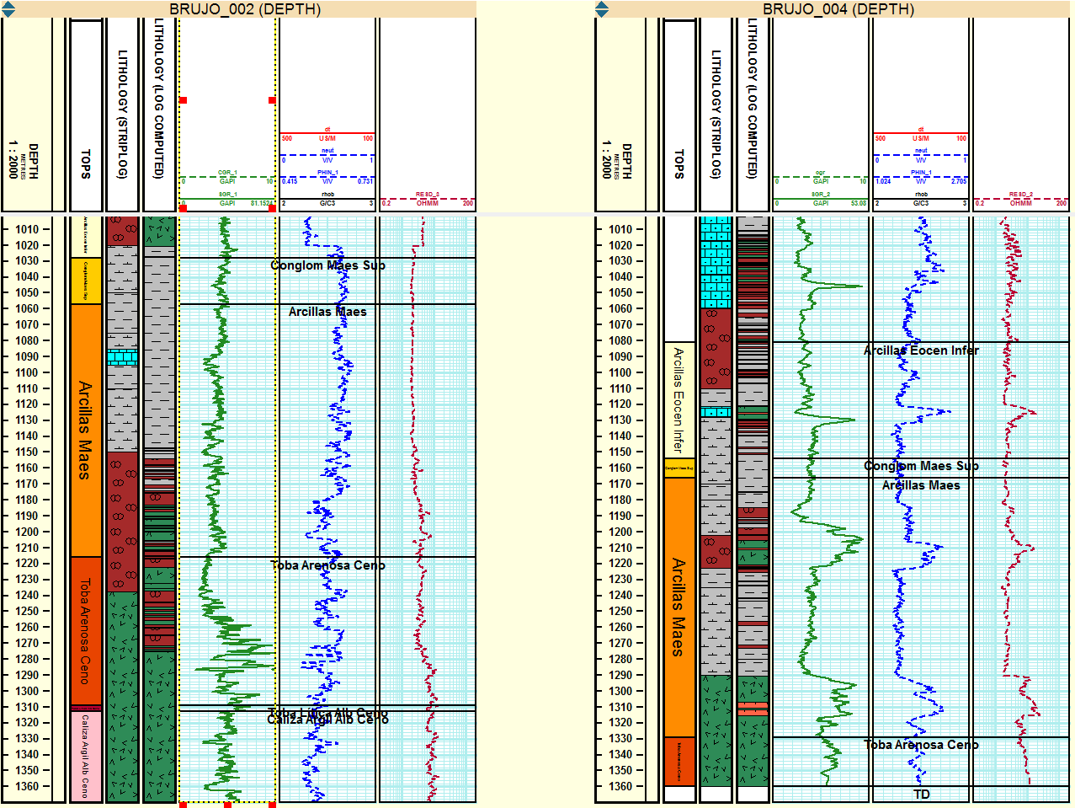

The reasons for the identification of the individual petrofacies was two-fold, firstly it would be a requirement when the assignment of pay cut offs was to be driven by rock type, and secondly, each petrofacies has its own matrix properties that are needed for porosity calculations.